Kubernetes Task-08
- Create and Test a Kubernetes Pod with an EmptyDir Volume

Step 1. Create the YAML file
vi emptydir-pod.yaml and add

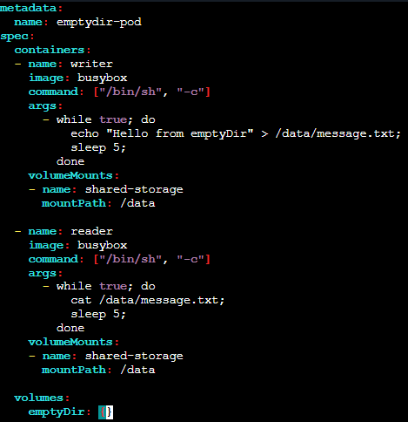

Step 2. Create the Pod
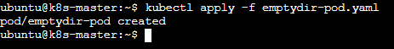

Verify:
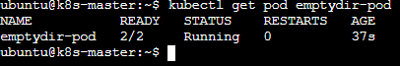

Step 3. Verify the volume
Check the file from the writer container:
Now check the same file from the reader container:

This proves that both containers are using the same emptyDir volume.

Step 4. Test data sharing
Create another file from the writer:
Read it from the reader:

Step 5. Verify the volume configuration
And under the containers, you should see:
Mounts

Step 6. Test emptyDir data deletion
Delete the Pod:
Recreate it:
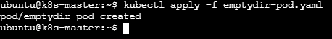
Then
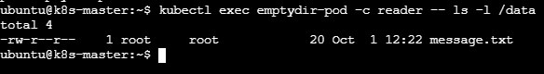

2. Configure a HostPath Volume in Kubernetes and Validate Data Persistence
Step 1: Create the Pod YAML
vi hostpath-pod.yaml and add
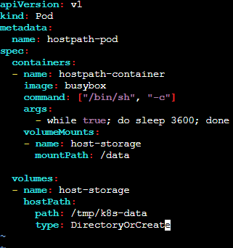
Save and exit.

Step 2: Create the Pod
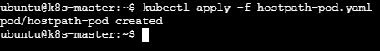
Verify:
Note the NODE where the Pod is running

Step 3: Create data inside the volume
Verify:

Step 4: Delete the Pod

Verify: Hostpath-pod is no longer available.
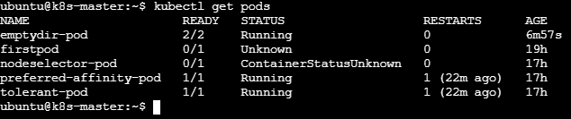

Step 5: Recreate the Pod
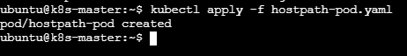
Check where it is running:

Step 6: Verify Data Persistence
Now check the file again:
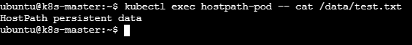
The data is still present even though the original Pod was deleted.

Step 7: Verify the HostPath on the Node
First find the node:
SSH into that same node, then:
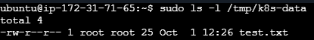
Read the content of file:
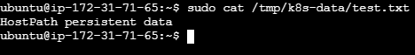
3. Deploy an Amazon EBS Volume Using Persistent Volume and Persistent Volume Claim (PVC)

Step 1: Check your worker node
Use your actual AZ in the next steps.

Step 2: Create an EBS volume in AWS
From your AWS EC2 console:
EC2 → Elastic Block Store → Volumes → Create volume
Use:
Volume type: gp3
Size: 10 GiB
Availability Zone: same AZ as your Kubernetes worker

Add us-east-1a
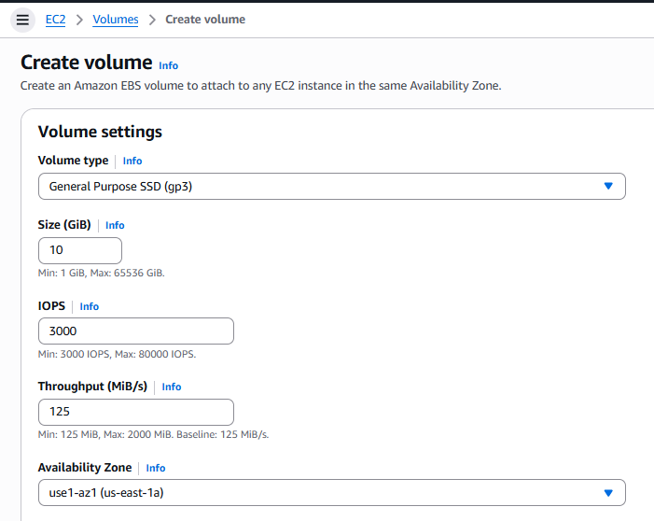
Click Create volume.

vol-0ab6143f1dd6175ba.

Note the above volume id.

Step 3: Install the AWS EBS CSI driver
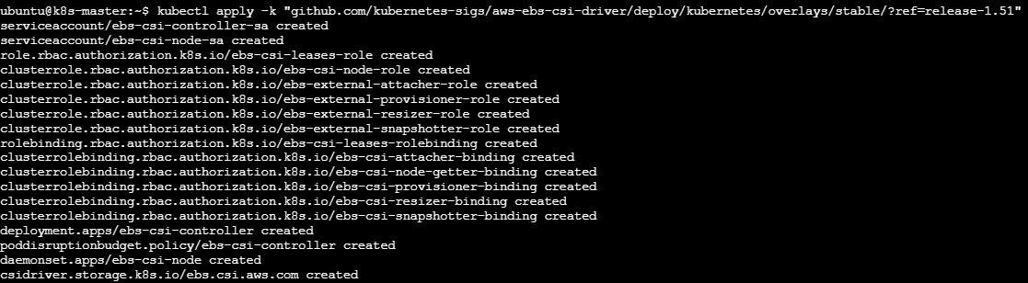

Then attach EBS CSI driver Role to all three machines.

Step 4: Create the PersistentVolume

On your Kubernetes master:
vi ebs-pv.yaml and add:
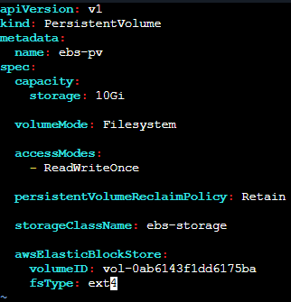

Replace vol-id with your actual EBS Volume ID.
Save and exit.

Apply it:
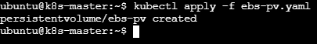

Check:

Step 5: Create the PVC
Create vi ebs-pvc.yaml and add

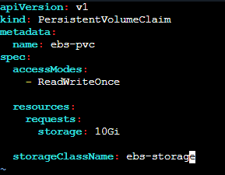

Save and exit.

Apply it:
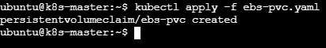

Check:
Also verify PV:

Step 6: Create a Pod using the PVC
Create: vi ebs-pod.yaml
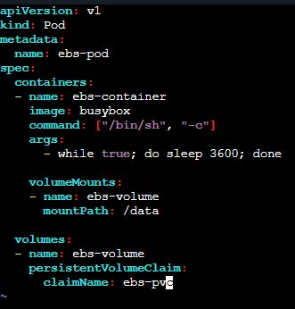
Save and exit.
Apply it:
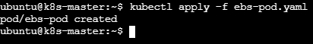

Check where it is running:

Step 7: Write data to the EBS volume

Step 8: Test persistence
Delete the Pod:
Check:
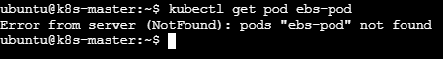
Now recreate the Pod:
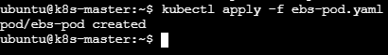

Verify

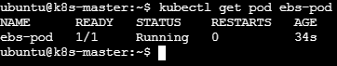

Now check the data:
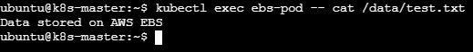
The data survived Pod deletion because it is stored on the EBS volume, not inside the Pod.
4. Set Up an Amazon EFS Volume and Attach it to Multiple Pods

Step 1: Check your EFS CSI driver
Run:
kubectl get pods -n kube-system | grep efs
kubectl get csidriver
You need to see:
efs.csi.aws.com
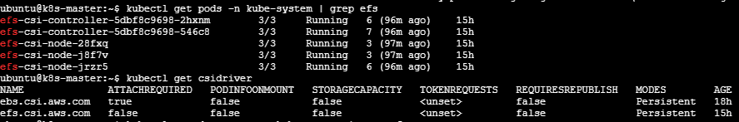
Also run:
kubectl get daemonset -n kube-system | grep efs
kubectl get deployment -n kube-system | grep efs
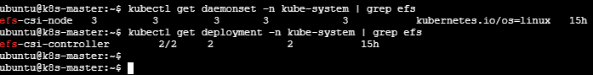

Step 2: Check your Kubernetes nodes
On the master:

Step 3 — Find the AWS Availability Zones
On worker1:
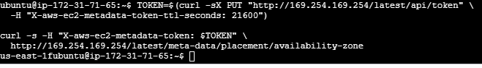
On worker2:
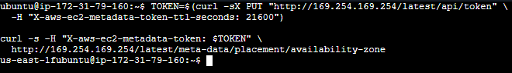

Step 4: Create an EFS filesystem in AWS
Go to:
AWS Console → EFS → File systems → Create file system
Create the EFS filesystem in the same VPC as your Kubernetes EC2 nodes.
After creation, copy the File system ID, for example:
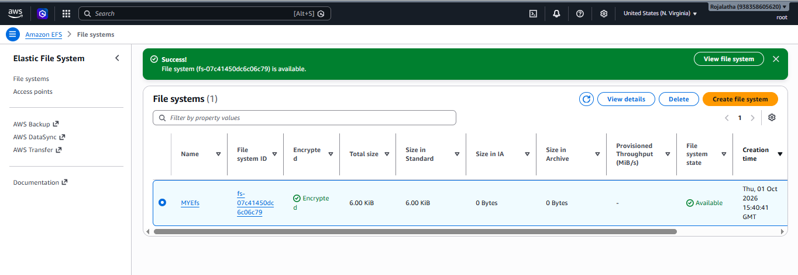
File system id: fs-07c41450dc6c06c79
Step 5: EFS security group
The EFS mount targets need to allow NFS TCP 2049 from the security group used by your Kubernetes EC2 nodes. AWS specifically requires inbound TCP 2049 on the EFS mount-target security group and outbound access from the EC2 nodes.

1. Open Security Groups
AWS Console → EC2 → Security Groups
Find the security group that is attached to your EFS mount target.
You can confirm it from:
EFS → File systems → your EFS → Network → Mount targets

2. Configure the EFS Mount Target
EFS → your filesystem → Network
Make sure there is a mount target in the Availability Zone where your worker nodes are located.

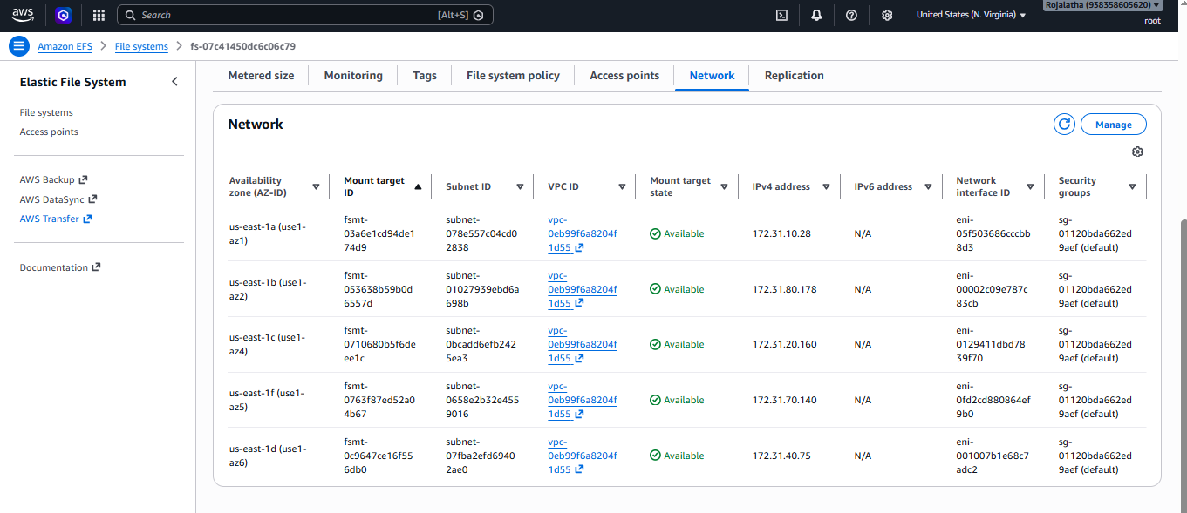
There will be a Security groups entry.

3. Edit inbound rules
Open that EFS security group → Inbound rules → Edit inbound rules → Add rule.
Configure:
Field | Value
Type | NFS
Protocol | TCP
Port | 2049
Source | Custom → select your Kubernetes EC2 node security group
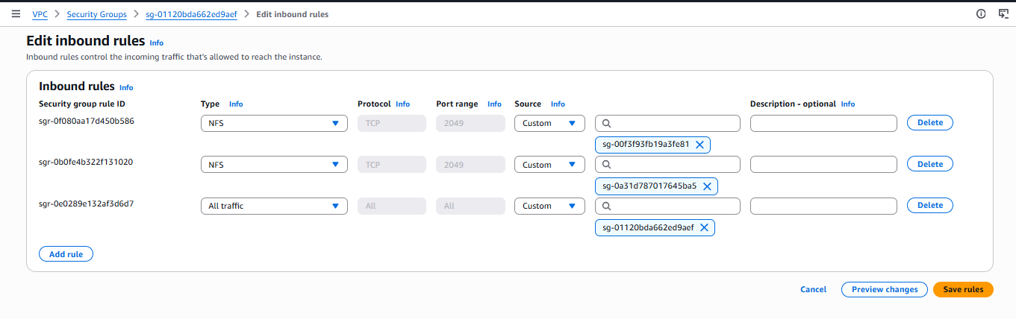
As two worker nodes have different security groups add two different NFS ports with each security group of node.

Step 5— Test EFS connectivity BEFORE creating Kubernetes resources
From each Kubernetes worker node, test:
nc -vz fs-07c41450dc6c06c79.efs.eu-north-1.amazonaws.com 2049
A successful result should look similar to:
On worker 1
On worker2:

Step 6— Create the StorageClass
Create vi efs-storageclass.yaml and add
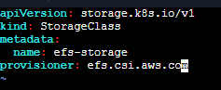
Save and exit.
Apply it:
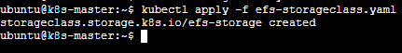
Verify:

Step 6: Create the PersistentVolume

Once the EFS CSI driver is available:
create: vi efs-pv.yaml and add

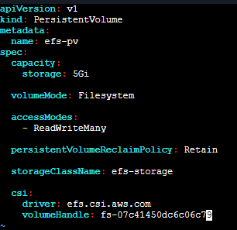
Save and exit.

Apply:
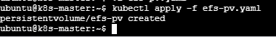

Check:
Step 5: Create the PVC
Create: vi efs-pvc.yaml and add
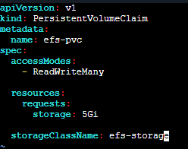

Save and exit.

Apply:
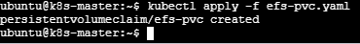

Check: For PVC
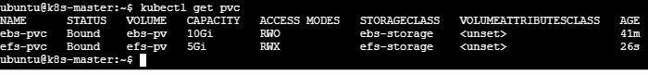
For pv:

Step 6: Create Pod 1
Create vi efs-pod1.yaml and add
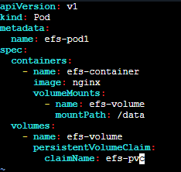

Save and exit.

Apply:
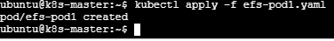

Check:

Step 7: Create Pod 2
Create: vi efs-pod2.yaml and add

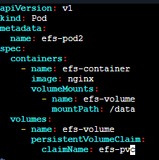

Save and exit.

Apply:
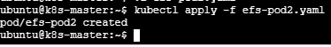
Check status:
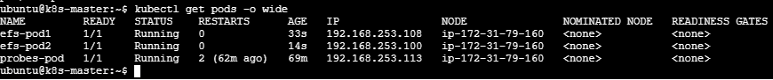
The Pods can be on different EC2 nodes, which is the key advantage we are demonstrating with EFS.

Step 8: Test shared EFS storage
Write from Pod 1:
Read from Pod 1:
Now read the same file from Pod 2:
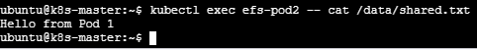
This proves both Pods are accessing the same EFS storage.

Step 9: Write from Pod 2
Read from Pod 1:
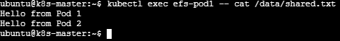

Step 10: Test persistence
Delete Pod 1:
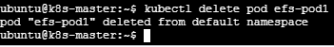
Recreate it:
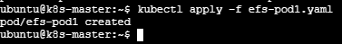
Wait and check the status:

Once its running read the data from pod 1:
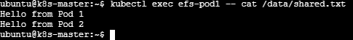

Thus, through this assignment we can say that all the pods are using shared file system.

5. Implement and Test Liveness and Readiness Probes in a Kubernetes Pod

Step 1. Create the YAML file
Create vi probes-pod.yaml and add
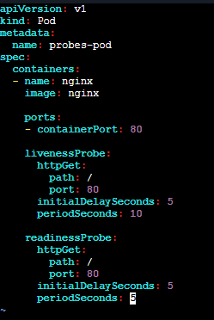
Save and exit.

Step 2. Create the Pod
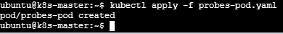
Check:
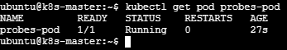
Here:
Liveness probe checks whether the container is alive.
Readiness probe checks whether the container is ready to receive traffic.

Step 3. Verify the probes
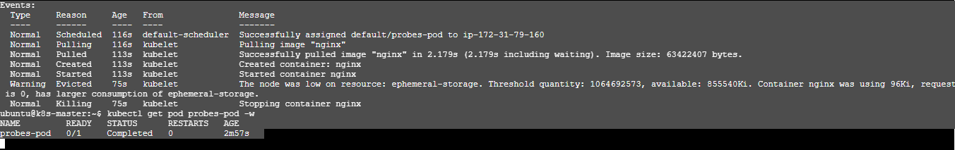
Step 4: Test the readiness probe
First confirm it is ready:
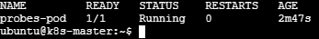
Now break the Nginx HTTP endpoint by removing the default index file:
Wait a few seconds and check the status: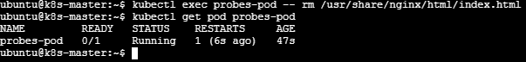
The readiness probe should eventually fail, causing the pod to show:

Step 5: Restore the endpoint
It should return to: 1/1
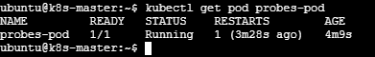

Step 6: Test the liveness probe
The liveness probe checks whether Nginx is responding. Stop Nginx:
kubectl get pod probes-pod
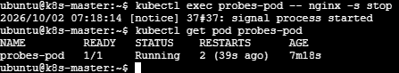
We see the RESTARTS count increase because Kubernetes restarts the container after the liveness probe fails.
Run kubectl describe pod probes-pod
Look for events such as: Liveness probe failed
